**Static Magnetic Field**

Magnetostatics 1

Force between two poles 1

Magnetic induction and magnetic field strength/intensity 2

Postulatess of magnetostatics 2

Biot-Savart’s Law 3

Magnetic Field Surrounding a Thin, Straight Conductor 5

Magnetic Field Due to a Curved Wire Segment 6

Magnetic Field on the Axis of a Circular Current Loop 7

The Magnetic Force between Two Parallel Conductors 8

Ampere’s Law and Applications 9

The Magnetic Field Created by a Long Current-Carrying Wire 10

The Magnetic Field Created by a Toroid 12

Vector Magnetic Potential 13

Magnetic Potential due to a Single Pole 13

Potential Magnetic Field Intensity Magnetic Dipole 14

Magnetic Moment 16

Magnetization 16

Magnetic field intensity 16

Permeability 17

# Magnetostatics

Magnetostatics is the study of magnetic fields in systems where the currents are steady (not changing with time). It is the magnetic analogue of electrostatics, where the charges are stationary. The magnetization need not be static; the equations of magnetostatics can be used to predict fast magnetic switching events that occur on time scales of nanoseconds or less. Magnetostatics is even a good approximation when the currents are not static — as long as the currents do not alternate rapidly. Magnetostatics is widely used in applications of micromagnetics such as models of magnetic storage devices as in computer memory. Magnetostatic focusing can be achieved either by a permanent magnet or by passing current through a coil of wire whose axis coincides with the beam axis.

# Force between two poles

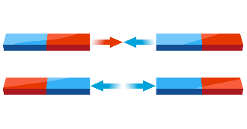The force of attraction or repulsion between two poles of a magnet is proportional to the product of the pole strengths and inversely proportional to the square of the distance between the poles. If the pole strengths of two poles are m1 and m2 Am and the distance between the poles in r then the force between them is

m2

m1

In free space it can be written in SI unit as

(1)

r

$F=\frac{μ_{0}}{4π}.\frac{m_{1}m_{2}}{r^{2}}$ N

Where $μ$ is the permeability of the medium between the poles which value in free space is TmA-1 (or Hm-1 or WbA-1m-1). In CGS system the value of $μ$ is 1 and it is dimensionless.

Let, m1 = m2 = m Am, r=1m. Now if the value of F=10-7 N, then m = 1Am. So, if two poles of equal strength is placed at 1m apart and the force between them is 10-7 N, then the strength of the poles will be 1Am.

# Magnetic induction and magnetic field strength/intensity

The area throughout the magnetic effect i.e. the magnetic force of attraction or repulsion exists is called the magnetic field of that magnet. Theoretically this field is ranged to infinity but according to Coulomb’s law this field reduces fast with increasing distance so that it extends not much.

The amount of force applied on a pole placed at some point in a magnetic field is called the magnetic induction **B** of that point. If m2=1Am, then to force on a unit pole due to m1 at a distance r is

(2)

B $=\frac{F}{m_{2}}= \frac{μ_{0}m_{1}}{4πr^{2}}$

*(i.e. and e.g. are both Latin abbreviations. E.g. stands for exempli gratia and means “for example.” i.e. is the abbreviation for id est and means “in other words.”)*

Here **B** is called the magnetic induction for m1 pole at r distance. Again B indicates the magnetic flux density. It is a vector quantity and its unit is T in SI system. (1T = 1Wb. m⁻² = 1NA-1m-1)

In many cases magnetic field is expressed in terms of its intensity **H**. Magnetic field intensity **H** and magnetic induction **B** are related as

B= $μ_{0}H$

(3)

From eqn 2 the magnetic intensity due to due to m1 pole a distance r is

(4)

$$H= \frac{m_{1}}{4πr^{2}}$$

# Postulates of magnetostatics

There are two postulates of magnetostatics, which are two of the four Maxwell’s equation.

**First postulates** states that the divergence of magnetic induction is zero i.e.

$$∇.B=0$$

This fact also implies that magnetic monopole is non-existing.

**Second postulates** states that, for steady state, the curl of magnetic induction is equals to $μ_{0}$ times the current density, i.e.

$$∇×B=μ_{0}J$$

Or, $$∇×H=J$$

[ for derivation follow class lecture]

# Biot-Savart’s Law

Shortly after Oersted’s discovery in 1819 that a compass needle is deflected by a current-carrying conductor, Jean-Baptiste Biot (1774–1862) and Félix Savart (1791–1841) performed quantitative experiments on the force exerted by an electric current on a nearby magnet. From their experimental results, Biot and Savart arrived at a mathematical expression that gives the magnetic field at some point in space in terms of the current that produces the field. That expression is based on the following experimental observations for the magnetic field dB at a point P associated with a length element ds of a wire carrying a steady current I (Fig.1):

• The vector d**B** is perpendicular both to d**s** (which points in the direction of the current) and to the unit vector $\hat{r}$ directed from d**s** to P.

• The magnitude of d**B** is inversely proportional to r2, where r is the distance from d**s** to P.

• The magnitude of d**B** is proportional to the current and to the magnitude ds of the length element ds.

• The magnitude of d**B** is proportional to sin $θ$, where $θ$ is the angle between the vectors d**s** and $\hat{r}$.

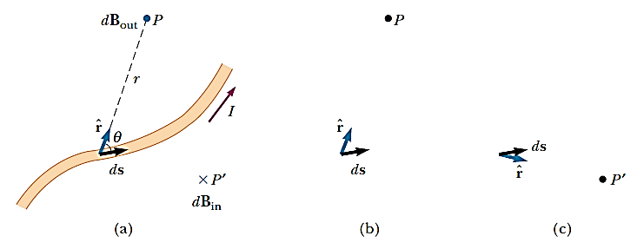

Fig.1: (a) The magnetic field d**B** at point P due to the current I through a length element d**s** is given by the Biot–Savart law. The direction of the field is out of the page at P and into the page at P’. (b) The cross product points out of the page when points toward P. (c) The cross product $ds×\hat{r}$ points into the page when $\hat{r}$ points toward P’.

These observations are summarized in the mathematical formula known today as the **Biot–Savart law**:

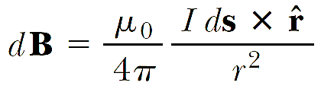

(1)

Where $μ_{0 }$ is a constant called the permeability of free space:



It is important to note that the field d**B** in Equation 1 is the field created by the current in only a small length element d**s** of the conductor. To find the total magnetic field **B** created at some point by a current of finite size, we must sum up contributions from all current elements Id**s** that make up the current. That is, we must evaluate **B** by integrating Equation 1

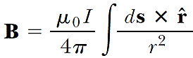

(2)

Where the integral is taken over the entire current distribution. This expression must be handled with special care because the integrand is a cross product and therefore a vector quantity. Although we developed the Biot–Savart law for a current-carrying wire, it is also valid for a current consisting of charges flowing through space, such as the electron beam in a television set. In that case, d**s** represents the length of a small segment of space in which the charges flow.

## Magnetic Field Surrounding a Thin, Straight Conductor

Consider a thin, straight wire carrying a constant current I and placed along the x axis as shown in Figure 2. Determine the magnitude and direction of the magnetic field at point P due to this current.

**Solution:** From the Biot–Savart law, we expect that the magnitude of the field is proportional to the current in the wire and decreases as the distance a from the wire to point P increases. We start by considering a length element d**s** located a distance r from P. The direction of the magnetic field at point P due to the current in this element is out of the page because $ds×\hat{r}$ is out of the page. In fact, since all of the current elements I d**s** lie in the plane of the page, they all produce a magnetic field directed out of the page at point P. Thus, we have the direction of the magnetic field at point P, and we need only find the magnitude.

Taking the origin at O and letting point P be along the positive y axis, with k being a unit vector pointing out of the page, we see that



Where  represents the magnitude of $ds×\hat{r}$. Because $\hat{r}$ is a unit vector, the unit of the cross product is simply the unit of d**s**, which is length. Substitution into Equatio1 gives

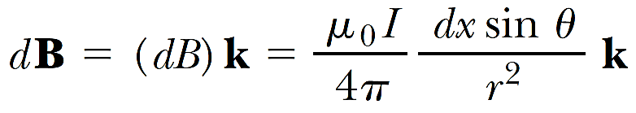

Because all current elements produce a magnetic field in the k direction, let us restrict our attention to the magnitude of the field due to one current element, which is

Fig. 2: (a) A thin, straight wire carrying a current I. The magnetic field at point P due to the current in each element d**s** of the wire is out of the page, so the net field at point P is also out of the page. (b) The angles 1 and 2, used for determining the net field. When the wire is infinitely long, 1 = 0 and 2 = 180°.

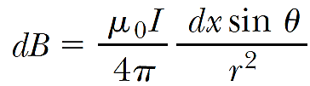

(1)

To integrate this expression, we must relate the variables $θ$, x, and r. One approach is to express x and r in terms of $θ$. From the geometry in Figure 2a, we have

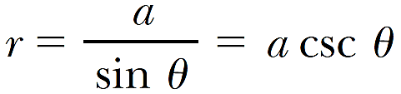

(2)

Because $tanθ=\frac{a}{(-x)}$ from the right triangle in Figure 2a (the negative sign is necessary because ds is located at a negative value of x), we have



Taking the derivative of this expression gives

(3)



Substitution of Equations (2) and (3) into Equation (1) gives

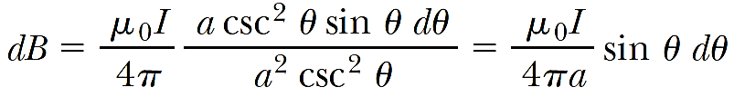

(4)

an expression in which the only variable is $θ$. We can now obtain the magnitude of the magnetic field at point P by integrating Equation (4) over all elements, subtending angles ranging from 1 to 2 as defined in Figure 2b:

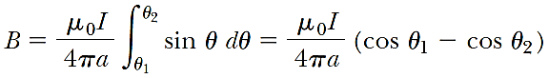

(5)

We can use this result to find the magnetic field of any straight current-carrying wire if we know the geometry and hence the angles 1 and 2. Consider the special case of an infinitely long, straight wire. If we let the wire in Figure 2b become infinitely long, we see that 1 = 0 and 2 = π for length elements ranging between positions $x=-∞$ and $x=+∞$. Because (cos1 – cos2) =(cos 0 - cos π) = 2, Equation 5 becomes

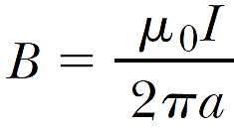

(6)

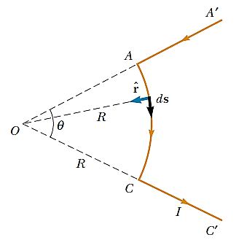Equations 5 and 6 both show that the magnitude of the magnetic field is proportional to the current and decreases with increasing distance from the wire, as we expected. Notice that Equation 6 has the same mathematical form as the expression for the magnitude of the electric field due to a long charged wire.

## Magnetic Field Due to a Curved Wire Segment

Calculate the magnetic field at point O for the current-carrying wire segment shown in Figure 3. The wire consists of two straight portions and a circular arc of radius R, which subtends an angle $θ$. The arrowheads on the wire indicate the direction of the current.

**Solution**

Fig. 3: The magnetic field at O due to the current in the curved segment AC is into the page. The contribution to the field at O due to the current in the two straight segments is zero.

The magnetic field at O due to the current in the straight segments AA’ and CC’ is zero because d**s** is parallel to along these paths; this means that $ds×\hat{r}=-0$. Each length element ds along path AC is at the same distance R from O, and the current in each contributes a field element dB directed into the page at O. Furthermore, at every point on AC, d**s** is perpendicular to $\hat{r};$ hence, $\left|ds×\hat{r}\right|=ds.$ Using this information and Equation 1, we can find the magnitude of the field at O due to the current in an element of length ds:

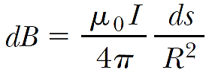

Because I and R are constants, we can easily integrate this expression over the curved path AC:

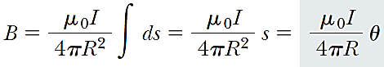

where we have used the fact that $s=Rθ$ with $θ$ measured in radians. The direction of **B** is into the page at O because $ds×\hat{r}$ is into the page for every length element.

## Magnetic Field on the Axis of a Circular Current Loop

Consider a circular wire loop of radius R located in the yz plane and carrying a steady current I, as shown in Figure 4. Calculate the magnetic field at an axial point P a distance x from the center of the loop.

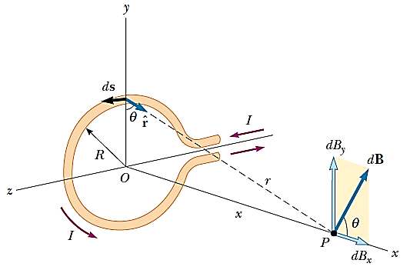**Solution**

In this situation, note that every length element d**s** is perpendicular to the vector $\hat{r}$ at the location of the element. Thus, for any element, $ds×\hat{r}$ = *(ds)(1)sin 90° = ds*. Furthermore, all length elements around the loop are at the same distance r from P, where $r^{2}=x^{2}+y^{2}.$ Hence, the magnitude of d**B** due to the current in any length element d**s** is

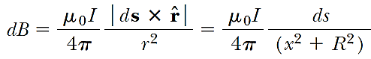

Fig. 4: Geometry for calculating the magnetic field at a point P lying on the axis of a current loop. By symmetry, the total field B is along this axis

(1)

The direction of d**B** is perpendicular to the plane formed by and ds, as shown in Figure 4. We can resolve this vector into a component dBx along the x axis and a component dBy perpendicular to the x axis. When the components dBy are summed over all elements around the loop, the resultant component is zero. That is, by symmetry the current in any element on one side of the loop sets up a perpendicular component of dB that cancels the perpendicular component set up by the current through the element diametrically opposite it. Therefore, the resultant field at P must be along the x axis and we can find it by integrating the components $dB_{x}=dBcosθ.$ That is, **B=**Bx**i** where

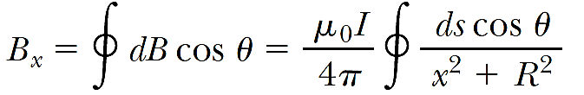

(2)

and we must take the integral over the entire loop. Because $θ$, x, and R are constants for all elements of the loop and because $cosθ=\frac{R}{\sqrt{x^{2}+R^{2}}}$, we obtain

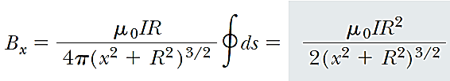

(3)

Where we have used the fact that  (the circumference of the loop). To find the magnetic field at the center of the loop, we set x=0 in Equation 3. At this special point, therefore,



(4)

It is also interesting to determine the behavior of the magnetic field far from the loop—that is, when x is much greater than R. In this case, we can neglect the term R2 in the denominator of Equation 3 and obtain

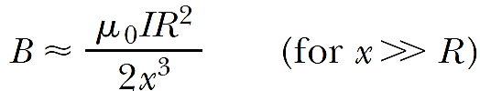

(5)

Because the magnitude of the magnetic moment $μ$ of the loop is defined as the product of current and loop area $μ=IπR^{2}$ for our circular loop—we can express Equation 5 as

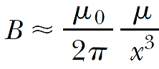

(6)

This result is similar in form to the expression for the electric field due to an electric dipole, 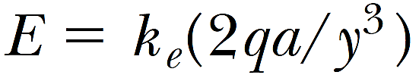.

## The Magnetic Force between Two Parallel Conductors

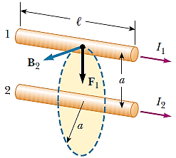Let us consider two long, straight, parallel wires separated by a distance a and carrying currents I1 and I2 in the same direction, as illustrated in Figure 5. We can determine the force exerted on one wire due to the magnetic field set up by the other wire. Wire 2, which carries a current I2, creates a magnetic field **B**2 at the location of wire 1. The direction of **B**2 is perpendicular to wire 1, as shown in Figure 5. The magnetic force on a length *l* of wire 1 is $F_{1}=I_{1}l×B_{2}.$ Because *l* is perpendicular to B2 in this situation, the magnitude of F1 is Because the magnitude of B2 is given by Equation

Fig. 5: Two parallel wires that each carry a steady current exert a force on each other.

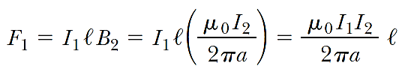

The direction of **F**1 is toward wire 2 because $l×B_{2}$ is in that direction. If the field set up at wire 2 by wire 1 is calculated, the force **F**2 acting on wire 2 is found to be equal in magnitude and opposite in direction to **F**1. This is what we expect because Newton’s third law must be obeyed. When the currents are in opposite directions (that is, when one of the currents is reversed in Fig. 5), the forces are reversed and the wires repel each other. Hence, we find that parallel conductors carrying currents in the same direction attract each other, and parallel conductors carrying currents in opposite directions repel each other. Because the magnitudes of the forces are the same on both wires, we denote the magnitude of the magnetic force between the wires as simply **F**B. We can rewrite this magnitude in terms of the force per unit length:

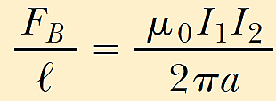

The force between two parallel wires is used to define the ampere as follows:

When the magnitude of the force per unit length between two long, parallel wires that carry identical currents and are separated by 1 m is 2 x 10-7 N/m, the current in each wire is defined to be 1 A.

# Ampere’s Law and Applications

Oersted’s 1819 discovery about deflected compass needles demonstrates that a current-carrying conductor produces a magnetic field. Figure 6a shows how this effect can be demonstrated in the classroom. Several compass needles are placed in a horizontal plane near a long vertical wire. When no current is present in the wire, all the needles point in the same direction (that of the Earth’s magnetic field), as expected. When the wire carries a strong, steady current, the needles all deflect in a direction tangent to the circle, as shown in Figure 6b. These observations demonstrate that the direction of the magnetic field produced by the current in the wire is consistent with the right-hand rule. When the current is reversed, the needles in Figure 30.8b also reverse.

Because the compass needles point in the direction of **B**, we conclude that the lines of **B** form circles around the wire, as discussed in the preceding section. By symmetry, the magnitude of B is the same everywhere on a circular path centered on the wire and lying in a plane perpendicular to the wire. By varying the current and distance a from the wire, we find that B is proportional to the current and inversely proportional to the distance from the wire, as Equation 30.5 describes.

Now let us evaluate the product **B**.d**s** for a small length element d**s** on the circular path defined by the compass needles, and sum the products for all elements over the closed circular path. Along this path, the vectors d**s** and **B** are parallel at each point (see Fig. 6b), so **B**.d**s** = B ds. Furthermore, the magnitude of B is constant on this circle and is given by Equation 30.5. Therefore, the sum of the products B ds over the closed path, which is equivalent to the line integral of **B**.d**s**, is

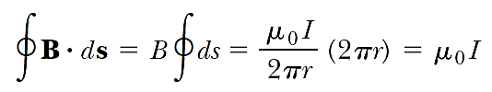

Where 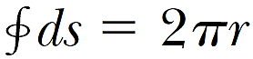 is the circumference of the circular path. Although this result was calculated for the special case of a circular path surrounding a wire, it holds for a closed path of any shape surrounding a current that exists in an unbroken circuit.

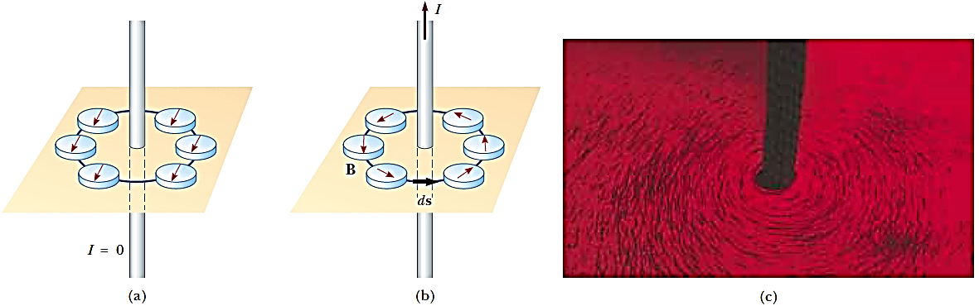

Fig. 6: (a) When no current is present in the wire, all compass needles point in the same direction (toward the Earth’s north pole). (b) When the wire carries a strong current, the compass needles deflect in a direction tangent to the circle, which is the direction of the magnetic field created by the current. (c) Circular magnetic field lines surrounding a current-carrying conductor, displayed with iron filings.

The general case, known as **Ampère’s law**, can be stated as follows:

**The line integral of B.ds around any closed path equals $μ_{0}$ I, where I is the total continuous current passing through any surface bounded by the closed path.**

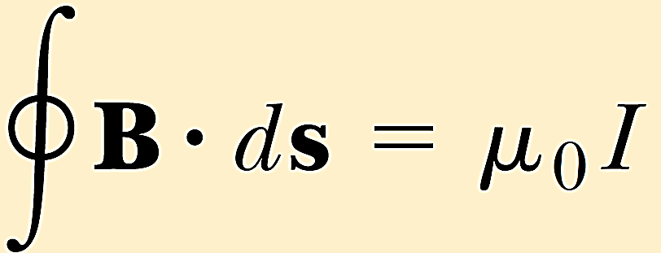

Ampère’s law describes the creation of magnetic fields by all continuous current configurations, but at our mathematical level it is useful only for calculating the magnetic field of current configurations having a high degree of symmetry. Its use is similar to that of Gauss’s law in calculating electric fields for highly symmetric charge distributions.

## The Magnetic Field Created by a Long Current-Carrying Wire

A long, straight wire of radius R carries a steady current I0 that is uniformly distributed through the cross-section of the wire (Fig. 7). Calculate the magnetic field at a distance r from the center of the wire in the regions r ≥ R and r $<$ R.

**Solution**

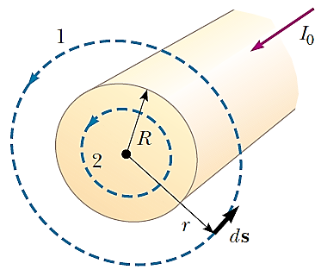For the case r ≥ R, we should get the same result we obtained before, in which we applied the Biot–Savart law to the same situation. Let us choose for our path of integration circle 1 in Figure 7. From symmetry, **B** must be constant in magnitude and parallel to ds at every point on this circle. Because the total current passing through the plane of the circle is I0, Ampère’s law gives

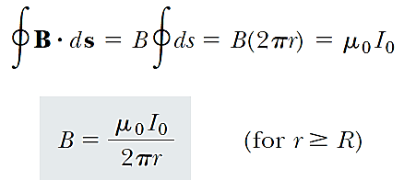

**Fig. 7:** A long, straight wire of radius R carrying a steady current I0 uniformly distributed across the cross-section of the wire.

(1)

Note how much easier it is to use Ampère’s law than to use the Biot–Savart law. This is often the case in highly symmetric situations. Now consider the interior of the wire, where r< R. Here the current I passing through the plane of circle 2 is less than the total current I0. Because the current is uniform over the cross-section of the wire, the fraction of the current enclosed by circle 2 must equal the ratio of the area πr2 enclosed by circle 2 to the cross-sectional area πR2 of the wire:

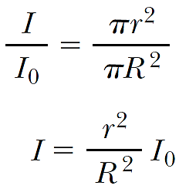

Following the same procedure as for circle 1, we apply Ampère’s law to circle 2:

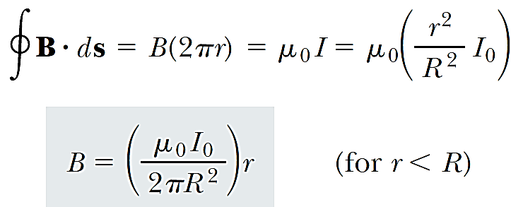

(2)

This result is similar in form to the expression for the electric field inside a uniformly charged sphere. The magnitude of the magnetic field versus r for this configuration is plotted in Figure 8. Note that inside the wire, B 0 as r 0. Note also that Equations 1 and 2 give the same value of the magnetic field at r = R, demonstrating that the magnetic field is continuous at the surface of the wire.

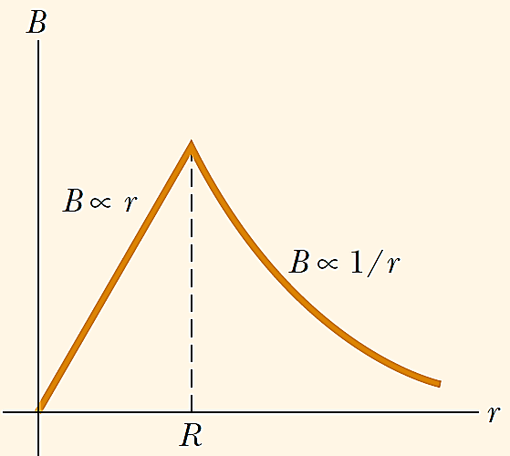

Fig. 8: Magnitude of the magnetic field versus r for the wire shown in Figure 7. The field is proportional to r inside the wire and varies as 1/r outside the wire.

## The Magnetic Field Created by a Toroid

A device called a toroid (Fig. 9) is often used to create an almost uniform magnetic field in some enclosed area. The device consists of a conducting wire wrapped around a ring (a torus) made of a nonconducting material. For a toroid having N closely spaced turns of wire, calculate the magnetic field in the region occupied by the torus, a distance r from the center.

**Solution**   
To calculate this field, we must evaluate  over the circle of radius r in Figure 9. By symmetry, we see that the magnitude of the field is constant on this circle and tangent to it, so **B**.d**s** = Bds. Furthermore, note that the circular closed path surrounds N loops of wire, each of which carries a current I. Therefore, the right side of Amperes law Equation is 0NI in this case.

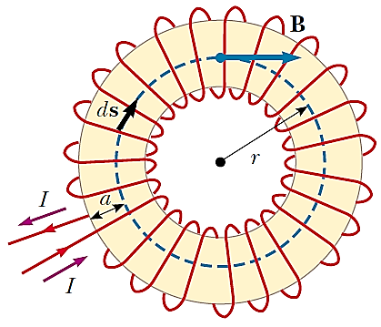

Fig. 9: A toroid consisting of many turns of wire. If the turns are closely spaced, the magnetic field in the interior of the torus (the gold-shaded region) is tangent to the dashed circle and varies as 1/r. The field outside the toroid is zero.

Ampère’s law applied to the circle gives

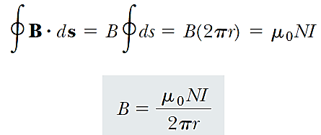

This result shows that B varies as 1/r and hence is nonuniform in the region occupied by the torus. However, if r is very large compared with the cross-sectional radius of the torus, then the field is approximately uniform inside the torus. For an ideal toroid, in which the turns are closely spaced, the external magnetic field is zero. This can be seen by noting that the net current passing through any circular path lying outside the toroid (including the region of the “hole in the doughnut”) is zero. Therefore, from Ampère’s law we find that B = 0 in the regions exterior to the torus.

# Vector Magnetic Potential

The magnetic vector potential **A** is a vector field that serves as the potential for the magnetic field. The curl of the magnetic vector potential is the magnetic field.



The magnetic vector potential is preferred when working with the Lagrangian in classical mechanics and quantum mechanics.

# Magnetic Potential due to a Single Pole

Let us consider, we have to calculate the potential at point P at distance r from a single pole of strength m. The force applied on a unit pole from N pole of strength m at distance x is

*F = $\frac{μ_{0}m}{4πx^{2}}$*

The work done to move a unit pole some distance dx against this force is

*dW =* ***F****.d****x***

= $- \frac{μ_{0}m}{4πx^{2}}dx$

Q

P

r

N **o**

So, the work done to bring a unit pole at point p is

$$w=-\int_{∝}^{r}{ \frac{μ_{0}m}{4πx^{2}}dx}$$

$$=-\frac{μ_{0}m}{4π}\int_{∝}^{r}{ \frac{1}{x^{2}}dx}$$

$$=\frac{μ_{0}m}{4π}{\left[\frac{1}{x}\right]}_{∝}^{r}$$

$$=\frac{μ_{0}m}{4πr}$$

So the potential due to unit pole is, $$V =\frac{μ_{0}m}{4πr}$$

# Potential Magnetic Field Intensity Magnetic Dipole

$$φ$$

$$H_{θ}$$

Hr

H

O

R

Q

$$θ$$

S

S

S

S

N

[Grab your reader’s attention with a great quote from the document or use this space to emphasize a key point. To place this text box anywhere on the page, just drag it.]

Let us consider NS be a permanent magnet of length and its pole strengths are +m and –m for N and S pole respectively. This small bar magnet can be considered as a magnetic dipole. **The potential at point P** at distance r from the center of this dipole is

(1)

$$V= \frac{μ_{0}m}{4πr_{1}}-\frac{μ_{0}m}{4πr_{2}}$$

$$=\frac{μ_{0}}{4π}\left(\frac{m}{r_{1}}-\frac{m}{r_{1}}\right)$$

$$=\frac{μ_{0}}{4π}\left(\frac{m}{r-l cosθ}-\frac{m}{r+l cosθ}\right)$$

$$=\frac{μ_{0}}{4π}\left(\frac{2ml cosθ}{r^{2}-l^{2}\cos^{2}θ }\right)$$

If the length of the dipole is very less than the distance r i.e. *l2<<r2* then,

(2)

Here M=2ml

$$V=\frac{μ_{0}}{4π}\left(\frac{M cosθ}{r^{2} }\right)$$

**Now the magnetic intensity at P in the direction OP is**

(3)

$$H_{r}= -\frac{1}{μ_{0}}\frac{dV}{dr}$$

$$= -\frac{d}{dr}\left(\frac{1}{4π}\frac{M cosθ}{r^{2} }\right)$$

$$= \frac{2}{4π}\frac{M cosθ}{r^{3} }$$

The magnetic field in the tangential direction is

$$H_{θ}= -\frac{1}{μ_{0}}\frac{1}{r}\frac{dV}{dθ}$$

$$H_{θ}= -\frac{1}{r}\frac{d}{dθ}\left(\frac{1}{4π}\frac{M cosθ}{r^{2} }\right)$$

(4)

$$= \frac{1}{4π}\frac{M sinθ}{r^{3} }$$

Now the total magnetic intensity $H=\sqrt{{{H_{r}}^{2}+H_{θ}}^{2}}$

(5)

$$=\frac{1}{4π}\sqrt{{{\left(\frac{M sinθ}{r^{3} }\right)}^{2}+\left(\frac{2M cosθ}{r^{3} }\right)}^{2}}$$

$$=\frac{M}{4πr^{3}}\sqrt{{{\left(sinθ\right)}^{2}+\left(2 cosθ\right)}^{2}}$$

$$=\frac{M}{4πr^{3}}\sqrt{{1+3cos}^{2}θ}$$

If the angle of H with Hr is $φ$ then the direction of H is

(6)

# http://www.questtutorials.com/media/static/xii/physics/03_Magnetic%20field%20and%20magnetic%20lines%20of%20force_files/370705050305.gifMagnetic Moment

Let us consider, a bar magnet of length 2l is placed in a magnetic field **B** with angle $θ$. If the pole strength of the magnet is m then the force exerted on each pole is mB which is opposite in direction. So these opposite forces create a couple of moment

C = mB.d

= mB. 2l sin $θ$

=MB sin $θ$

Where, M = 2ml, which is called the magnetic moment of this bar magnet.

# Magnetization

The magnetization is defined as the magnetic moment induced per unit volume in response to the applied magnetic field. If the induced magnetic moment is dm in volume dv then the magnetization M is

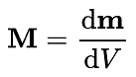

This is better illustrated through the following relation:

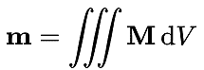

Where m is an ordinary magnetic moment and the triple integral denotes integration over a volume. Magnetization or magnetic polarization is the vector field that expresses the density of permanent or induced magnetic dipole moments in a magnetic material. The origin of the magnetic moments responsible for magnetization can be either microscopic electric currents resulting from the motion of electrons in atoms, or the spin of the electrons or the nuclei. Net magnetization results from the response of a material to an external magnetic field, together with any unbalanced magnetic dipole moments that may be inherent in the material itself; for example, in ferromagnets. Magnetization is not always uniform within a body, but rather varies between different points. Magnetization also describes how a material responds to an applied magnetic field as well as the way the material changes the magnetic field, and can be used to calculate the forces that result from those interactions. It can be compared to electric polarization, which is the measure of the corresponding response of a material to an electric field in electrostatics. Physicists and engineers usually define magnetization as the quantity of magnetic moment per unit volume. It is represented by a pseudovector M.

# Magnetic field intensity

The magnetic fields generated by currents and calculated from Ampere's Law or the Biot-Savart Law are characterized by the magnetic field B measured in Tesla. But when the generated fields pass through magnetic materials which themselves contribute internal magnetic fields, ambiguities can arise about what part of the field comes from the external currents and what comes from the material itself. It has been common practice to define another magnetic field quantity, usually called the "magnetic field strength" designated by H. It can be defined by the relationship

H = $\frac{B}{μ_{m}}$ = $\frac{B}{μ_{0}}$- M

and has the value of unambiguously designating the driving magnetic influence from external currents in a material, independent of the material's magnetic response. The relationship for B can be written in the equivalent form

B = μ0(H + M)

H and M will have the same units, amperes/meter. To further distinguish B from H, B is sometimes called the magnetic flux density or the magnetic induction. The quantity M in these relationships is called the magnetization of the material.

Another commonly used form for the relationship between B and H is

B = μmH

Where

μ = μm = Kmμ0

μ0 being the magnetic permeability of space and Km the relative permeability of the material. If the material does not respond to the external magnetic field by producing any magnetization, then Km = 1.

The unit for the magnetic field strength H can be derived from its relationship to the magnetic field B, B=μH. Since the unit of magnetic permeability μ is N/A2, then the unit for the magnetic field strength is: T/(N/A2) = (N/Am)/(N/A2) = A/m

An older unit for magnetic field strength is the oersted: 1 A/m = 0.01257 oersted.

# Permeability

In electromagnetism, permeability is the measure of the ability of a material to support the formation of a magnetic field within itself otherwise known as distributed inductance in Transmission Line Theory. Hence, it is the degree of magnetization that a material obtains in response to an applied magnetic field. Magnetic permeability is typically represented by the (italicized) Greek letter *µ.* The term was coined in September 1885 by Oliver Heaviside. The reciprocal of magnetic permeability is magnetic reluctivity (A measure of the resistance of a material to the establishment of a magnetic field within it, equal to the ratio of the intensity of the magnetic field to the magnetic induction of the material).

In SI units, permeability is measured in henries per meter (H/m), or equivalently in newtons (kg⋅m/s2) per ampere squared (N·A−2). The permeability constant *µ0*, also known as the magnetic constant or the permeability of free space, is a measure of the amount of resistance encountered when forming a magnetic field in a classical vacuum. Until May 20, 2019, the magnetic constant has the exact (defined) value µ0 = 4π × 10−7 H/m ≈ 12.57 × 10−7 H/m.