**Waves**

Vibration: 2

Free Vibration: 2

Criteria of Vibration 2

Simple Harmonic Motion: 2

Characteristics of S.H.M. / Criteria of S.H.M. 2

Differential Equation of Simple Harmonic Oscillator 2

Solution of Differential Equation of Simple Harmonic Motion 3

Total Energy and Average Energy 4

Combination of Simple Harmonic Oscillations 6

Torsional Pendulum 6

Reduced Mass 8

Damped Oscillation 9

Forced Oscillation 9

Resonance 9

Progressive Wave 10

Power and Intensity of Wave 11

Wave Intensity 13

Stationary Wave 14

# Vibration:

A vibration is a kind of motion that changes the direction of sense and after a regular interval of time. It is also a to and fro motion.

# Free Vibration:

A closed vibratory system is given and initial excitation and is allowed to vibrate without further influence executes free vibration.

# Criteria of Vibration

a) It has restoring force

b) It has inertia of motion

c) It has also initial excitation

# Simple Harmonic Motion:

When a body moves such that its acceleration is proportional to its displacement from its equilibrium position or any other fixed point at its path and be always directed towards that point then the motion of the body is called simple harmonic motion. Simple harmonic motion can be represented by

$$x= Acos(ωt+φ)$$

# Characteristics of S.H.M. / Criteria of S.H.M.

a) The motion is periodic motion in a particular case

b) the acceleration of the body is proportional to its displacement from its equilibrium position

c) The acceleration of the body is directed towards a certain fixed point

d) The motion is isochronous because the expression for the time period $\left(T = 2π\sqrt{\frac{m}{k}}\right)$ is independent of the amplitude of the motion

e) The equation does not conclude the motion of the particle along the circle

f) Acceleration varies directly as its distance from the equilibrium point.

# Differential Equation of Simple Harmonic Oscillator

Let a mass attached with a spring on a frictionless horizontal surface (whose one end is fixed). The spring is extended and released. The mass displaced by an amount ‘x’ to the right. Restoring force Fr is developed and it executes simple harmonic vibration and the setup is called harmonic oscillator.

According to Hooke’s law restoring force is proportional to displacement (x), i.e.

$$F_{r}∝x$$

$$F_{r}=kx$$

Where k is the stiffness constant or spring constant or force constant.

We get from Newton’s 2nd law of motion

(1)

$$F_{a}=m\ddot{x}$$

From Newton’s 3rd law of motion

(2)

$$F_{a}=-F_{r}$$

$$m\ddot{x}=-kx$$

$$m\ddot{x}+kx=0$$

$$\ddot{x}+\frac{k}{m}x=0$$

$\ddot{x}+ω^{2}x=0$ [Where $ω^{2}=\frac{k}{m}$ = angular   
frequency or angular velocity]

$\frac{d^{2}x}{dt^{2}}+ω^{2}x=0$

This is the equation of simple harmonic motion.

# Solution of Differential Equation of Simple Harmonic Motion

Equation (1) or (2) is 2nd order, 1st degree, and linear homogeneous differential equation with constant coefficient. It is solved by trial solution.

Let the trial solution of the equation is

$x=e^{Pt}$ Where P is constant, t is time

$$\dot{x}={Pe}^{Pt}$$

$$\ddot{x}=P^{2}e^{Pt}$$

Substituting these values in equation 1 we get

$$P^{2}e^{Pt}+{ω^{2}e}^{Pt}=0$$

$$e^{Pt}\left(P^{2}+ω^{2}\right)=0$$

Since $e^{Pt}=0$ is the trivial solution, mathematically expectable but not physically expectable. So

$$P^{2}+ω^{2}=0$$

$$P=±\sqrt{-ω^{2}}$$

$$P=±iω$$

So trial solution becomes, $x_{1}=e^{iωt}$ and $x_{2}=e^{-iωt}$

And the general solution is

(3)

$$x=Ce^{iωt}+C'e^{-iωt}$$

Here C and C’ are combination of coefficient.

(4)

$x=C(cosωt+i sinωt)+C'(cosωt-i sinωt)$ [using De Moivre's theorem]

$$x=(C+C^{'})cosωt+i(C-C^{'}) sinωt$$

If x is to be real, x must involve two solutions:

If C and C’ are real

$$x=(C+C^{'})cosωt$$

If C and C’ are imaginary

$$x=(C-C^{'}) sinωt$$

If C and C’ are either real or imaginary, we get only one solution instead of two which we cannot accept. Hence C and C’ are must be complex.

Let *C = a + ib*

*C’ = a’ – ib’*

Now C + C’ = (a + a’) – i(b + b’)

and C – C ’ = (a – a’) – i(b – b’)

Putting these values in equation

**Home work: The motion of a particle is given by $x=80sin98t cm$. Find the (i) Displacement at 55 second, (ii) Velocity and (iii) Acceleration of the particle.**

# https://d1whtlypfis84e.cloudfront.net/guides/wp-content/uploads/2018/02/19170158/graph.gifTotal Energy and Average Energy

Let a particle executing simple harmonic motion is subjected to the action of a restoring force. So its energy can be both kinetic and potential. If no energy is dissipated, then the amplitude of displacement remains constant and it will follow that the law of conservation of mechanical energy holds for harmonic oscillation.

The displacement,

$$x=Acos\left(ωt+φ\right)$$

Where, A=amplitude, $ω=$ angular frequency, $φ=$ initial phase.

Now, velocity v = $\dot{x}$

$$=-Aωsin\left(ωt+φ\right)$$

From the equation of motion, we have, *F = -kx*

Where k is the stiffness constant.

So the work done, *dw = -Fdx = -(-kx)dx = kxdx*

The negative sign indicates that work is done against force. The potential energy is obtained by summing all the increments of work (*kxdx*) done by the system against the restoring force over the range zero to x. Thus the potential energy at any instant/point is

$$P.E.=\int_{0}^{x}{kxdx}=k\int_{0}^{x}{xdx}=\frac{1}{2}kx^{2}$$

$$=\frac{1}{2}kA^{2}\cos^{2}(ωt+φ)$$

The maximum potential energy occurs at $x=±A$ and is

(1)

$${P.E.}_{max}=\frac{1}{2}kA^{2}$$

The kinetic energy at any instant is

(2)

[As $mω^{2}=k]$

$$K.E.=\frac{1}{2}m{\dot{x}}^{2}$$

$$=\frac{1}{2}m{\left\{-Aωsin\left(ωt+φ\right)\right\}}^{2}$$

$$=\frac{1}{2}mA^{2}ω^{2}\sin^{2}\left(ωt+φ\right)$$

$$=\frac{1}{2}kA^{2}\sin^{2}\left(ωt+φ\right)$$

So

$${K.E.}_{max}=\frac{1}{2}kA^{2}$$

Now, the total energy E at any instant is

$$E=P.E. +K.E.$$

$$=\frac{1}{2}kA^{2}\cos^{2}\left(ωt+φ\right)+\frac{1}{2}kA^{2}\sin^{2}\left(ωt+φ\right)$$

$$=\frac{1}{2}kA^{2}\left\{\sin^{2}\left(ωt+φ\right)+\cos^{2}\left(ωt+φ\right)\right\}$$

$$=\frac{1}{2}kA^{2}$$

This equation shows that the total energy does not depends upon time and it is constant.

**Now the average PE** for one complete time period is

$${P.E.}_{av}=\frac{1}{T}\int_{0}^{T}{\frac{1}{2}kA^{2}\sin^{2}\left(ωt+φ\right)}$$

$$=\frac{kA^{2}}{4T}\int_{0}^{T}{2\sin^{2}\left(ωt+φ\right)}dT$$

$$=\frac{kA^{2}}{4T}\int_{0}^{T}{\left[1-cos2\left(ωt+φ\right)\right]dT}$$

$$=\frac{kA^{2}}{4T}{\left[t\right]}_{o}^{T}$$

$$=\frac{1}{4}kA^{2}$$

Similarly the average kinetic energy is

$${K.E.}_{av}=\frac{1}{4}kA^{2}$$

So the average total energy per one complete time period is

$$\frac{1}{4}kA^{2}+\frac{1}{4}kA^{2}=\frac{1}{2}kA^{2}$$

Thus the average KE of a harmonic oscillator is equal to the average potential energy and each is equal to one half of the total energy.

# Combination of Simple Harmonic Oscillations

Consider the superposition of two simple harmonic motions

*x*(*t*)=*x*1(*t*)+*x*2(*t*)=*A*1cos(*ω*1*t*+*ϕ*1)+*A*2cos(*ω*2*t*+*ϕ*2).

The first motion *x*1(*t*) is periodic with period *T*1=2*πω*1 and the second motion *x*2(*t*) is periodic with period *T*2=2*πω*2. Clearly the sum of both is only periodic if *nT*1=*mT*2 where *n* and *m* are positive integers. To see this, simply write

*x*(*t*+*nT*1)=*x*1(*t*+*nT*1)+*x*2(*t*+*mT*2)=*x*1(*t*)+*x*2(*t*)=*x*(*t*).

Moreover if the period of both harmonic motions is the same *ω*1=*ω*2=*ω* , we can write

*x*(*t*) = *A*1[cos(*ωt*)cos*ϕ*1−sin(*ωt*)sin*ϕ*1]+*A*2[cos(*ωt*)cos*ϕ*2−sin(*ωt*)sin*ϕ*2]

= [*A*1cos*ϕ*1+*A*2cos*ϕ*2]cos(*ωt*)−[*A*1sin(*ϕ*1)+*A*2sin*ϕ*2]sin(*ωt*)

= *A* cos(*ωt*+*ϕ*),

Where used the sum rule cos(*α*+*β*)=cos*α*cos*β*−sin*α*sin*β*, and we defined

*A*cos*ϕA*sin*ϕ*=*A*1cos*ϕ*1+*A*2cos*ϕ*2=*A*1sin*ϕ*1+*A*2sin*ϕ*2.

This can be generalized to an arbitrary sum of harmonic motions with the same period:

∑*iAi*cos(*ωt*+*ϕi*)=*A*cos(*ωt*+*ϕ*).

Another way to understand this, is to note that the harmonic equation is a linear differential equation; any linear combination of solutions is also a solution.

**Conclusion**

The sum of two harmonic motions with frequencies *ω*1 and *ω*2 is periodic if the ratio *ω*1/*ω*2

is a positive rational number. If the ratio is irrational, the resulting motion is not periodic. If, moreover, the frequencies of the two harmonic motions are equal, the resulting motion is also a harmonic motion with the same frequency.

# Torsional Pendulum

A cylinder is twisted by the angle $θ$ and then released. It will execute torsional vibration. When a cylinder or wire is twisted, filament of the cylinder are displaced, these displacement constitutes two equal and opposite restoring force known as twisting couple.

And restoring torque due to the elasticity of the material of the cylinder is,

(1)

$$τ_{r}=-cθ$$

And, we know

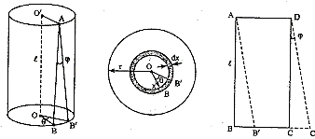

(2)

$$c=\frac{nπr^{4}}{2l}$$

Where, C= twisting couple per unit twist

r = radius of cylinder

n= modulus of rigidity

*l*= length of cylinder

Now, equation of motion is

(3)

[Where I is the moment of inertia]

$$I\ddot{θ}=-cθ$$

$$I\ddot{θ}+cθ=0$$

$$\ddot{θ}+\frac{c}{I}θ=0$$

$$\ddot{θ}+\frac{c}{I}θ=0$$

$$\ddot{θ}+ω_{a}^{2}θ=0$$

Where $ω_{a}=\sqrt{\frac{c}{I}}$ the angular frequency of the vibration

The equation 3 is simple harmonic, so the cylinder will execute simple harmonic motion.

The solution of the equation is

$$θ=θ_{0}\cos\left(ω_{a}t+δ\right)$$

So the period of oscillation

$$T=\frac{2π}{ω_{a}}=2π\sqrt{\frac{I}{c}}$$

$$T^{2}=4π^{2}\frac{I}{c}$$

$$T^{2}c=4π^{2}I$$

$$T^{2}\frac{nπr^{4}}{2l}=4π^{2}I$$

$$n=\frac{8πIl}{r^{4}T^{2}}$$

This is the required equation of modulus of rigidity from the time period of motion.

# Reduced Mass

Reduced mass, in physics and astronomy, value of a hypothetical mass introduced to simplify the mathematical description of motion in a vibrating or rotating two-body system. The equations of motion of two mutually interacting bodies can be reduced to a single equation describing the motion of one body in a reference frame centered in the other body. The moving body then behaves as if its mass were the product of the two masses divided by their sum. That quantity is called the reduced mass.

It is a quantity which allows the two-body problem to be solved as if it were a one-body problem. Note, however, that the mass determining the gravitational force is not reduced. In the computation one mass can be replaced with the reduced mass, if this is compensated by replacing the other mass with the sum of both masses. The reduced mass is frequently denoted by μ (mu). It has the dimensions of mass, and SI unit kg.

Given two bodies, one with mass m1 and the other with mass m2, the equivalent one-body problem, with the position of one body with respect to the other as the unknown, is that of a single body of massμ = 1 1 m 1 + 1 m 2 = m 1 m 2 m 1 + m 2 , {\displaystyle \mu ={\cfrac {1}{{\cfrac {1}{m_{1}}}+{\cfrac {1}{m_{2}}}}}={\cfrac {m_{1}m_{2}}{m_{1}+m_{2}}},\!\,}

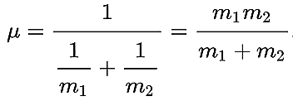

Where the force on this mass is given by the force between the two bodies.

The reduced mass is always less than or equal to the mass of each body: μ ≤ m1, μ ≤ m2 and has the reciprocal additive property:

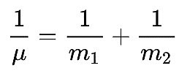

Which by re-arrangement is equivalent to half of the [harmonic mean](https://en.wikipedia.org/wiki/Harmonic_mean). In the special case that m 1 = m 2 {\displaystyle m_{1}=m_{2}} m1=m2:

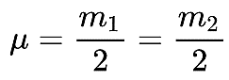

μ = m 1 2 = m 2 2 {\displaystyle {\mu }={\frac {m_{1}}{2}}={\frac {m_{2}}{2}}\,\!} If m1>>m2m 1 ≫ m 2 {\displaystyle m_{1}\gg m_{2}} , then μ m2 μ ≈ m 2 {\displaystyle \mu \approx m_{2}}

# Damped Oscillation

When a vibrating body vibrates in an air or any other resisting medium, the amplitudes of vibration does not remain constant but decreases gradually and ultimately it comes to rest after sometime. Such vibration is known as damped vibration/oscillation.

In other words vibration which ceases after sometimes due to some opposing forces as like as air, electric resistance, frictional forces etc. is called damped vibration. The opposing force is called damping force. In most cases, damping force is proportional to velocity of the body but directed opposite to it. It is called viscous drag.

So damping force: $F_{d}∝-\dot{x}$

$$F_{d}=-b\dot{x}$$

Where b is called damping coefficient. Damping coefficient depends on the nature of the medium.

Characteristics of damped vibration:

i) It continues for short time

ii) For real system, vibration ceases (stop) with time due to some opposing external forces known as damping force

iii) For most of the cases where velocity is small, damped force may be taken to be proportional to the velocity.

# Forced Oscillation

The time period of a body executing simple harmonic motion depends on the dimensions of the body and its elastic properties. The vibrations of such a body die out with time due to dissipation of energy. If some external periodic force is constantly applies on the body it continues oscillating under the influence of such external force. Such vibrations of the body are called forced vibration.

For a vibrating system, when the frequencies of the driving and driven system are not the same, the natural frequency of the oscillator dies out soon and it begins to oscillate with the frequency of impressed periodic force. In this system the vibration so kept up are called forced vibration. Sound production system is an example of force vibration.

# Resonance

When the natural frequency of a vibrating system becomes same as the frequency of the applied periodic force, the vibrating medium vibrates with the maximum amplitude. This phenomenon is known as resonance. The frequency at which the second body starts oscillating or vibrating at higher amplitude is called the resonant frequency of the body. The best examples of resonance can be observed in various musical instruments around us.

Whenever any person hits, strikes, strums, drums or tweaks any musical instrument, the instrument is set into oscillation or vibration at the natural frequency of vibration of the instrument. A unique standing wave pattern defines each frequency of vibration as a specific instrument. These natural frequencies of a musical instrument are known widely as the harmonics of the specified instrument. If a second interconnected object or instrument vibrates or oscillates at that specified frequency then the first object can be forced to vibrate at a frequency higher than its natural harmonic frequency. This phenomenon is known as resonance i.e. one object vibrating or oscillating at the natural frequency of another object forces the other object to vibrate at a frequency higher than its natural frequency.

A classic example of resonance is the swinging of a person sitting on a swing. A swing is a very good example of an object in oscillating motion. Initially, the motion is slow and the swing doesn’t extend to its maximum potential. But once when the swing reaches its natural frequency of oscillation, a gentle push to the swing helps it maintain that amplitude of swing all throughout due to resonance.

In an ideal situation, with no friction at all, even that slight push won’t be necessary once the swing reaches its natural frequency for it to sustain the maximum amplitude forever. Also almost all musical instruments, like the flute, guitar etc work on the principle of resonance itself.

# Progressive Wave

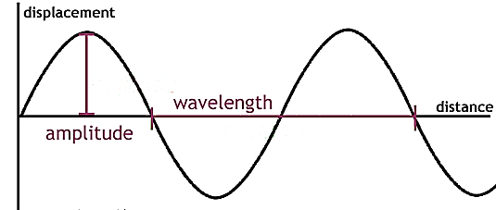A progressive wave is defined as the onward transmission of the vibratory motion of a body in an elastic medium from one particle to the successive particle.

**Equation of a plane progressive wave**

An equation can be formed to represent generally the displacement of a vibrating particle in a medium through which a wave passes. Thus each particle of a progressive wave executes simple harmonic motion of the same period and amplitude differing in phase from each other.

Let us assume that a progressive wave travels from the origin O along the positive direction of X axis, from left to right. The displacement of a particle at a given instant is

y = a sin ωt            …... (1)

Where *a* is the amplitude of the vibration of the particle and ω = 2π*n*. The displacement of the particle P at a distance *x* from O at a given instant is given by,

y = a sin (ωt - φ)           …... (2)

If the two particles are separated by a distance *λ*, they will differ by a phase of 2π. Therefore, the phase φ of the particle P at a distance *x* is  φ = (2π/λ) x

y = a sin (ωt - 2πx/λ)           …... (3)

Since ω = 2πn = 2π (v/λ), the equation is given by,

y = a sin [(2πvt/λ) - (2πx/λ)]

y =  a sin 2π/λ (vt – x)         …... (4)

Since, ω = 2π/T, the equation (3) can also be written as,

y = a sin 2π (t/T – x/λ)          …... (5)

If the wave travels in opposite direction, the equation becomes,

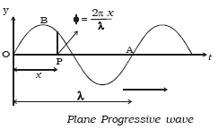y = a sin 2π (t/T + x/λ)             …... (6)

**(i) Variation of phase with time**  The phase changes continuously with time at a constant distance. At a given distance *x* from O let φ1 and φ2 be the phase of a particle at time *t*1 and *t*2 respectively.

φ1 = 2π (t1/T - x/λ)

φ2 = 2π (t2/T - x/λ)

φ2 –  φ1 = 2π (t2/T – t1/T) = 2π/T (t2 – t1)

φ = (2π/T) t This is the phase change $∆$ φ of a particle in time interval $∆$ t. If $∆$*t* = T, $∆$ φ = 2π. This shows that after a time period T, the phase of a particle becomes the same.

**(ii) Variation of phase with distance**  At a given time t phase changes periodically with distance *x*. Let φ1 and φ 2 be the phase of two particles at distance *x*1 and *x*2 respectively from the origin at a time t. Then,

φ1 = 2π (t/T - x1/λ)

φ2 = 2π (t/T - x2/λ)

So, φ2 – φ1 = – 2π/λ (x2 – x1)

Thus,  φ = – 2π/λ ($∆$ x)

The negative sign indicates that the forward points lag in phase when the wave travels from left to right. When $∆$*x* = λ, $∆$ φ = 2π, the phase difference between two particles having a path difference λ is 2π.

# Power and Intensity of Wave

As a mechanical wave propagates in a medium, it transfers energy form one particle to another and the successive particles get the disturbance.

In [Figure 1](https://www.physicskey.com/37/wave-energy-power-and-intensity#fig8.9) we consider a transverse wave in a string travelling in positive x-direction of our coordinate system. We consider a particular point p in the string which is disturbed by the wave.

The string on the left of the point p exerts tension on the point which has two components namely Fx and Fy. The transverse force Fy exerts transverse force on the particle and hence does work on the particle. Note that the component Fx is the tension the string would have in undisturbed condition of the string. The wave has constant amplitude and constant frequency.

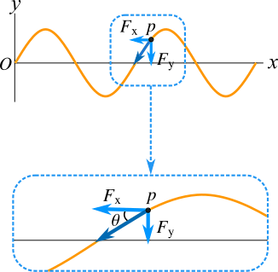  
Figure 1

The slope at the point p is the negative of the ratio Fy/Fx because Fy is negative but the slope is positive. The slope is also equal to the derivative of wave function with respect to position x keeping time t constant, therefore the slope at the point p is

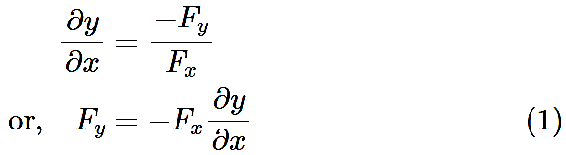

The power is the rate of doing work and the instantaneous power at the point p is the product of downward force Fy and the downward velocity vy at that point. So,

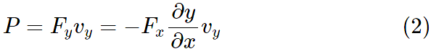

The wave function for a simple harmonic wave travelling in positive x-direction is y=Acos(kx−ωt) and we can find;

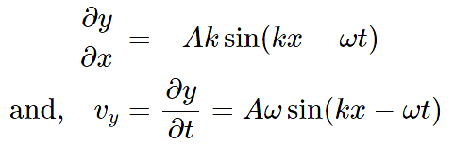

Therefore, substituting the values of ∂y/∂x and vy in Eq. [(2)](https://www.physicskey.com/37/wave-energy-power-and-intensity#mjx-eqn-2) , we get the power which is



We know the speed of web is related with transverse force Fx as Fx=v2μ and k=ω/v, the above equation can be rewritten as



The value of sin2 function oscillates between 0 and 1 and hence its average value is 1/2. So, the average value of sin2(kx−ωt) in the above equation is ½ and the average power is

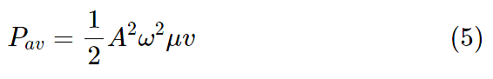

The above equation shows the average rate of energy transfer, that is average power of a simple harmonic or sinusoidal wave along a string is proportional to the square of amplitude, square of angular frequency, linear density of the string and the wave speed.

# Wave Intensity

Sound waves spread out in three-dimensional space from the source of sound so the sound wave is three dimensional wave while the transverse wave in a string is one dimensional. We use power to define the strength of one dimensional waves, however *intensity* is used for three dimensional waves.

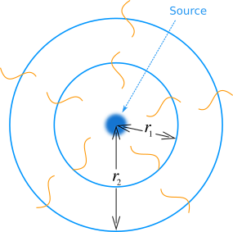  
Figure 2

Intensity of a wave is the average rate of energy transfer per unit area perpendicular to the direction of the propagation of the wave. It's the same as the average power of the wave per unit area.

We can see in [Figure 2](https://www.physicskey.com/37/wave-energy-power-and-intensity#fig8.10) that a sound source emits sound waves in three dimensional space. The imaginary spherical surfaces of radius r1 and r2 enclose the source of sound. The average power Pav through both spherical surfaces is the same. Now the intensity I1 through the spherical surface of radius r1 is I1=Pav/4πr12 and the intensity I2 through the spherical surface of radius r2 is I2=Pav/4πr22 . Therefore,

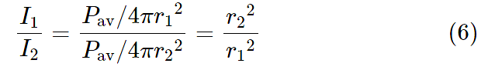

The above equation tells us that the intensity of a sound wave is inversely proportional to the square of distance from the source of sound. The above equation is called inverse square law for three dimensional waves.

# Stationary Wave

When two progressive waves of same amplitude and wavelength travelling along a straight line in opposite directions superimpose on each other, stationary waves are formed.

**Analytical method** Let us consider a progressive wave of amplitude a and wavelength λ travelling in the direction of X axis.

y1 = a sin 2π [t/T – x/λ]         …... (1)

This wave is reflected from a free end and it travels in the negative direction of X axis, then

y2 = a sin 2π [t/T + x/λ]         …... (2)

According to principle of superposition, the resultant displacement is,

y = y1+y2 = a [sin 2π (t/T – x/λ) + sin 2π (t/T + x/λ)]

= a [2sin (2πt/T) cos  (2πx/λ)]

So, y = 2a cos (2πx/λ) sin (2πt/T)         …... (3)

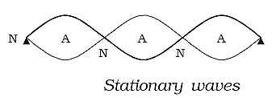This is the equation of a stationary wave. (a) At points where x = 0, λ/2, λ, 3λ/2, the values of cos 2πx/λ = ±1 ∴ A = + 2a. At these points the resultant amplitude is maximum. They are called antinodes as shown in figure. (b) At points where x = λ/4, 3λ/4, 5λ/4..... the values of cos 2πx/λ = 0. ∴ A = 0. The resultant amplitude is zero at these points. They are called nodes. The distance between any two successive antinodes or nodes is equal to λ/2 and the distance between an antinode and a node is λ/4. (c) When t = 0, T/2, T, 3T/2, 2T, then sin 2πt/T = 0, the displacement is zero. (d) When t = T/4, 3T/4, 5T/4 etc,....sin 2πt/T = ±1,  the displacement is maximum.

**Characteristics of stationary waves**  The waveform remains stationary. Nodes and antinodes are formed alternately. The points where displacement is zero are called nodes and the points where the displacement is maximum are called antinodes. Pressure changes are maximum at nodes and minimum at antinodes.  All the particles except those at the nodes, execute simple harmonic motions of same period. Amplitude of each particle is not the same, it is maximum at antinodes decreases gradually and is zero at the nodes. The velocity of the particles at the nodes is zero. It increases gradually and is maximum at the antinodes. Distance between any two consecutive nodes or antinodes is equal to λ2, whereas the distance between a node and its adjacent antinode is equal to λ/4. There is no transfer of energy. All the particles of the medium pass through their mean position simultaneously twice during each vibration. Particles in the same segment vibrate in the same phase and between the neighboring segments, the particles vibrate in opposite phase.

# 